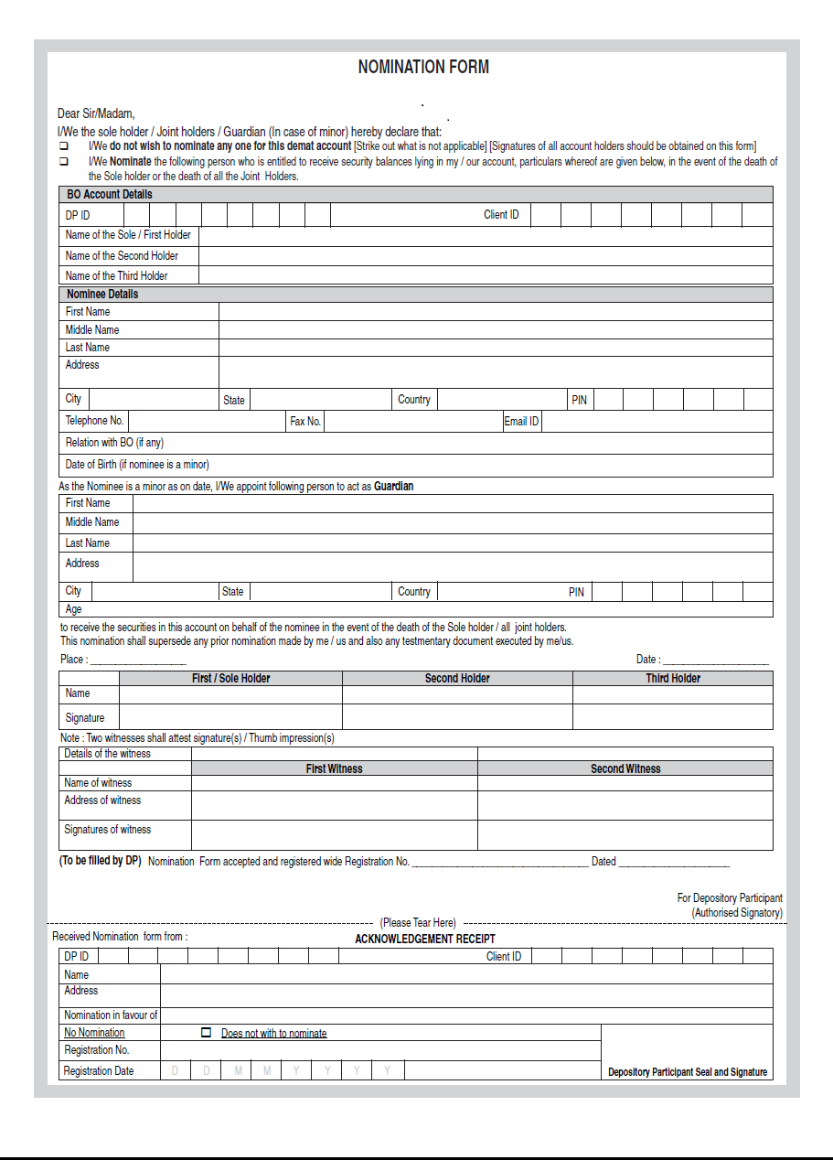
Encl : ID proof (PAN/ADHAR COPY) & Witnesses of 2 members.

